Class: SYMCA Div: B  Semester: III | Course Code: MCA01605  Course Name: Web Programmin Laboratory |  | Batch: S2
Name: Ajit Bajarang Mali |  | Roll No: 52140
CO No: CO606.1 |  | Assignment No: 01
PRACTICAL SUBMISSION RECORD- A.Y. 2024-25

Title: Create a static HTML page that displays the following output using frame
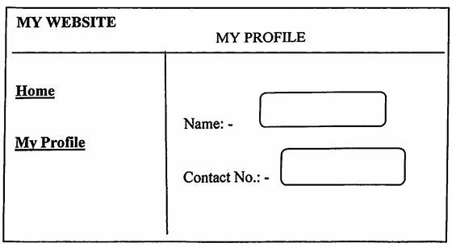
Code:
index.html

<!DOCTYPE html>
<html>
<head>
<title>My Website</title>
</head>
<frameset rows="15%,*">
<frame src="header.html" name="headerFrame" noresize>
<frameset cols="25%,*">
<frame src="menu.html" name="menuFrame" noresize>
<frame src="profile.html" name="mainFrame">
</frameset>
</frameset>
</html>

menu.html

<!DOCTYPE html>
<html>
<head>
<title>Menu</title>
</head>
<body class="menu">
<a href="home.html" target="mainFrame">Home</a>
<a href="profile.html" target="mainFrame">My Profile</a>
</body>
</html>

header.html

<!DOCTYPE html>
<html>
<head>
<title>Header</title>
</head>
<body class="header">
<span>MY PROFILE</span>
</body>
</html>

home.html

<!DOCTYPE html>
<html>
<head>
<title>Home</title>
</head>
<body>
<h3 class="home">Welcome to Home Page</h3>
</body>
</html>

profile.html

<!DOCTYPE html>
<html>
<head>
<title>My Profile</title>
</head>
<body>
<form class="profile-form">
<label>Name: - </label>
<input type="text"><br><br>
<label>Contact No.: - </label>
<input type="text">
</form>
</body>
</html>

Output:

